FortnaPlus Sorter Simulation Guide

Document Version: 1.1
Date: 4/22/2013

Revision History

Revision | Date | Author | Revision Summary
0.1 | 19Apr2013 | Paul D Rotter | Initial Release
1.1 | 12/04/2013 | Barry Conklin | Updated Column Descriptions
1.2 | 12/06/2013 | Barry Conklin | Changed logic to handle auto-generated scans and scans from a table to use the same logic.

Table of Contents
1 Introduction 4
1.1 Document Objective 4
1.2 References 4
1.3 Document Conventions 4
1.3.1 Definitions, Acronyms, and Abbreviations 4
2 Basic Sorter Operation 5
2.1 Sorter Configuration 5
2.2 Sorter Simulation Configuration 5
2.2.1 Batches 5
2.2.2 Simulation Menu Configuration 6
2.3 Simulation Scan Options 9
2.3.1 Auto-Generated Scans 9
2.3.2 Static Scan Simulation List 10
2.3.3 Static Scan Simulation List Specifications 11
2.3.4 Sorter Simulation Control Panel 12

Introduction
The FortnaPlus software application features the ability to simulate the operation of a sorter from carton induction and scanning through carton divert. This feature is available in FortnaPlus version 10.0 and newer.

Document Objective
The purpose of this guide is to describe the abilities of the Sorter Simulation feature, how to configure a sorter simulation, and how to control and manage a simulation.

References
This document references the following documents:
- Sorter Control Software – R8.0 V1.2.docx
  - available in Redmine at /Projects/FortnaPlus Control/Documents/Sorter Confiuration Utilities V8.0
- Sorter Configuration Check List V8.0.docx
  - available in Redmine at /Projects/FortnaPlus Control/Documents/Sorter Confiuration Check List V8.0

Document Conventions

Definitions, Acronyms, and Abbreviations
Carton - a container used to hold product
CRR – Carton Route Request, a message from Automation Controller to Level II requesting a route for a given carton
DCM – Divert Confirm Message, a message from Automation Controller to Level II providing confirmation of a carton divert event

Basic Sorter Operation
The operation of a FortnaPlus sorter can be described as the following sequence of events designed to transport cartons to designated sortation lanes:
- Sorter Induction
  - A carton blocks a photo-eye as it enters the sorter conveyor
- Carton Identification
  - FortnaPlus receives scanner data as a carton passes through the sorter scan zone marrying the data to the carton’s tracking record
- Routing Request/Assignment
  - FortnaPlus sends a CRR (Container Route Request) message to Level II and receives a reply specifying the carton’s destination lane
- Carton Divert
  - When a carton reaches its destination lane, FortnaPlus operates a divert mechanism
- Divert Confirmation
  - After a carton has been diverted, FortnaPlus sends a DCM (Divert Confirm Message) to Level II

Sorter Configuration
For a detailed description of sorter configuration, reference the following two documents:

- Sorter Control Software – R8.0 V1.2.docx
- Sorter Configuration Check List V8.0.docx

The scope of this document is configuration and operation of a sorter simulation. This document assumes the sorter(s) to be simulated have been properly configured as described in the above referenced documents.

Sorter Simulation Configuration

Batches
Open the Batches menu:
Configuration Menu | Standard Controls | Batches

Activate the sorter simulation batch:
Column | Description | Simulation
File_Name | The name of the process that should be run. The name should be unique in the Batches menu. In order to run the simulation a new entry needs to be added. | SorterSimulator
Description | The description of the Batches entry. | Sorter Simulation
CurrentNum | Not used. | 0
HowOften | Determine how many increments are needed to run the process. This value must be greater than 0 for the process to run. | 1
Increment | Determine the interval for running the process. Most of the entries make sense. In this case the SORT SIM process needs to run on each tick. Use INVALID to run on each tick. Also see Type. | INVALID
CurrentStat | The current increment count until the process runs. If the HowOften field is greater than 0 you may see this field incrementing. You can also test if a batch is really running by putting a non-zero value in the field. If the process is running it will be reset to 0. | Calculated
WasStat | Used by the software for Types Elapsed and Absolute. | Calculated
Type | The type of interval to trigger the process. The Count value is a count of the times the process runs. The SORT SIM process should run each time the process runs. | Count
Process | The Automation Controller process to run the function in. | SORT
InternalProc | Batches that are run from the GUI and SERV.
InternalProcCtrl | Batches that are run from CTRL and SORT. | SrtSim SORT
Machine | The name of the machine the batch should be run on. | Name of your Machine.
All Machines | Determines if the batch is run on all machines. | N
DoFile | Execute the name in File_Name as a program. | N

Simulation Menu Configuration
Open the SrtSimConfig menu:
Configuration Menu | Sorter Utilities | Cont Sim Config

Configure a sorter simulation as shown in the table below: SrtSimConfig
Column | Description | Value
Name | The name of the simulation configuration. The name should be unique in the table and row 0 should not be used. | TestSim
EnableSrt | Enables the Sorter Simulation. Set this last. | Y
Status | A status column for the simulation. | Calculated
AppSorter | The AppSorter Row for the Sorter being simulated. | Select the AppSorter Record for the sorter that will be simulated.
NumContSrt | The number of containers to induct into the sorter simulation. | Enter the number of cartons that will be simulated
CurContSrt | The number of containers that have been inducted on to the simulated sorter. | Initially set to 0, updated by the software as it runs
SimShifter | The Shifter to induct the simulated containers. You can match the AppSorter to the Shifter by looking at the SrtZoneLane and Sorter Outpoints menu. | Select the shifter record for the sorter that will be simulated
CreateSorterTmr | To run a shifter for simulation, a Sorter Timer is required. To create the timer if it does not already exist, and to allow the simulation software to enable and disable the timer, turn the push button “ON”. If the button is turned “OFF” the simulator will not change the sorter encoder type, when the simulator is “Enabled”.  The “Encoder Type” is set to a “Timer Type” encoder when the simulator is enabled. The “Encoder Type” is set back to “Real Encoder” when the “Enable” for the simulator is turned “OFF”. | Turn “ON” to create a “Encoder Timer”
ShifterTimerHalt | If the SimShifter uses a timer based encoder then setting this to Y will halt the simulated conveyor in the event of an error. An error may occur if a lane is not available, or if a HeartBeat Error has occurred. | Y
NumCharScan | The number of characters to use in the simulated scan. Maximum should be 20. Should be at least the sum of characters in NumContSrt, PreFixString, PostFixString. The scan value will be the PreFixString, the CurContSrt, and the PostFixString concatenated together. Do not use if you are using the ScanSimMenu. | 0
ScanDevice | The scan device for the sorter. | Select the associated scan device
ScaleDevice | The scale device for the sorter if there is one. | Select the associated scale device
ScaleString | This will be the value passed in the CRR sScaleData field. Do not use if you are using the ScanSimMenu.
PreFixString | A string to add to the start of the container number. Do not use if you are using the ScanSimMenu.
PostFixString | A string to add to the end of the container number. Do not use if you are using the ScanSimMenu.
InPoint | The IO of the sorter’s induction photo eye. | Select the Induct Point associated with the shifter that will be simulated
InductDumpPt | Inducts boxes from the previous simulated shifter. Set to “N” on the first shifter and “Y” on each additional shifter you want to pass the containers to. As the container hits the dump point on the prior shifter, the induct for this shifter will induct the carton. | Set based on each shifter associated with the sorter
Length | The length of each inducted box in ticks. | Enter the length of the simulated box in ticks
Gap | The distance in ticks between the end of the first box the and the start of the next box. | Enter the gap in ticks, between boxes
ForceRxStat | In the ScnScanDevice menu, if you have not selected SimScan as the ScanType then select this box. Doesn’t work unless your scan point is set to the induct point. | Set as needed
SimCrrCsu | Determines if the simulator simulates DCM and CSU messages. Set to “Y”, if the simulator needs to generate a CSU and DCM, as soon as the CRR Response is received. | N
ScanSimPoint | The update point listed in the ScnScanDevice menu for your ScanDevice. Only configure this for the shifter with a scanner. | Select the scan update point
ScanSimMenu | A menu containing a list of scans. The CartonID field is used to PnA simulation. Only configure this for the shifter with a scanner. | Select the file as needed
SimScanFile | A file to load the ScanSimMenu from. The table in the ScanSimMenu can be entered manually. Only configure this for the shifter with a scanner. | Select file as needed
LoadFile. | Causes the file listed in the SimScanFile entry to be loaded. | Off
WrapScanList | Causes the scan list to wrap if there are more containers than scans. Check if not communicating to a real Level 2. | Off
ResetSimulation | Resets the simulation. | Off
pCurrLength | The remaining length in ticks for the currently inducting box. | Calculated
pCurrGap | The remaining length in ticks until the next box inducts. | Calculated
pCurrSimRecord | The next Sim Record that will be extracted from the “ScanSimMenu”. The column is updated after each scan is simulated. | Calculated

The menu above contains the information necessary to simulate cartons on a sorter. The next section describes the two methods available for simulating sorter scan data.

Simulation Scan Options
The sorter simulation feature offers two methods of simulating induction scans. This section describes both options and how to configure them.

Auto-Generated Scans
This method dynamically builds scan data as cartons are inducted based on format information supplied in the following SrtSimConfig menu fields:
- PreFixString – all simulated scan strings begin with the prefix supplied in this field
- PostFixString – all simulated scan strings end with the postfix supplied in this field
- NumCharScan – the number of characters the carton ID should include

When a carton is simulated onto the sorter, it is given a carton ID which is a sequence number incremented for each carton created. The sequence number comes from the CurContSrt field which increments as each carton is created.

Example:
- PreFixString = “START”
- PostFixString = “END”
- NumCharScan = 10

Using the example data above, the first three cartons inducted onto the sorter would receive the following auto-generated scan data:
- “START0000000000END”
- “START0000000001END”
- “START0000000002END”

This method is useful when the content of the scan data is inconsequential or the Level II routing is being simulated by FortnaPlus.

When utilizing this method, the following fields should be set as described in the table below:
Column | Description | Value
Name | The name of the simulation configuration. The name should be unique in the table and row 0 should not be used. | TestSim
EnableSrt | Enables the Sorter Simulation. Set this last. | Y
Status | A status column for the simulation. | Calculated
AppSorter | The AppSorter Row for the Sorter being simulated. | Select the AppSorter Record for the sorter that will be simulated.
NumContSrt | The number of containers to induct into the sorter simulation. | Enter the number of cartons that will be simulated
CurContSrt | The number of containers that have been inducted on to the simulated sorter. | Set to 0, updated by the software as it runs
SimShifter | The Shifter to induct the simulated containers. You can match the AppSorter to the Shifter by looking at the SrtZoneLane and Sorter Outpoints menu. | Select the shifter record for the sorter that will be simulated
CreateSorterTmr | To run a shifter for simulation, a Sorter Timer is required. To create the timer if it does not already exist, and to allow the simulation software to enable and disable the timer, turn the push button “ON”. | Turn button “ON”.
NumCharScan | The number of characters to use in the simulated scan. Maximum should be 20. Should be at least the sum of characters in NumContSrt, PreFixString, PostFixString. The scan value will be the PreFixString, the CurContSrt, and the PostFixString concatenated together. Do not use if you are using the ScanSimMenu. | Value between 1 and 20
ScanDevice | The scan device for the sorter. | Select the associated scan device
ScaleDevice | The scale device for the sorter if there is one. | Select the associated scale device
ScaleString | This will be the value passed in the CRR sScaleData field. Do not use if you are using the ScanSimMenu. | Enter scale vale Example: “3.5”
PreFixString | A string to add to the start of the container number. Do not use if you are using the ScanSimMenu. | Enter prefix: Example: “100”
PostFixString | A string to add to the end of the container number. Do not use if you are using the ScanSimMenu. | Enter postfix: Example: “XY”
InPoint | The IO of the sorter’s induction photo eye. | Select the Induct Point associated with the shifter that will be simulated
InductDumpPt | Inducts boxes from the previous simulated shifter. Set to N on the first shifter and Y on each shifter you want to pass the containers to. As the container hits the dump point the induct the next shifter will trigger. | Set based on each shifter associated with the sorter
Length | The length of each inducted box in ticks. | Enter the length of the simulated box in ticks
Gap | The distance in ticks between the end of the first box the and the start of the next box. | Enter the gap in ticks, between boxes
SimCrrCsu | Determines if the simulator simulates DCM and CSU messages. Set to “Y”, if the simulator needs to generate a CSU and DCM, as soon as the CRR Response is received. | N
ScanSimMenu | A menu containing a list of scans. The CartonID field is used to PnA simulation. Only configure this for the shifter with a scanner. | None
SimScanFile | A file to load the ScanSimMenu from. The table in the ScanSimMenu can be entered manually. Only configure this for the shifter with a scanner. | None
LoadFile. | Causes the file listed in the SimScanFile entry to be loaded. | Off
WrapScanList | Causes the scan list to wrap if there are more containers than scans. Check if not communicating to a real Level 2. | Off
ResetSimulation | Resets the simulation. | Off
pCurrLength | The remaining length in ticks for the currently inducting box. | Calculated
pCurrGap | The remaining length in ticks until the next box inducts. | Calculated
pCurrSimRecord | The next Sim Record that will be extracted from the “ScanSimMenu”. The column is updated after each scan is simulated. | Calculated

Static Scan Simulation List
This method retrieves predefined simulation scans from an external scan list as each carton is inducted. This option is useful when specific scan data must be simulated in order to match Level II testing requirements. The simulation scan list is supplied by an external text file which can be dynamically selected to change simulation scan lists quickly and easily. See section 2.3.3 for the simulation scan list file specifications.
When using this method, the auto-generation fields (PreFixString, PostFixString, NumCharScan, ScaleString) fields are not used.

The Static Scan Simulation requires the following configuration information:

Column | Description | Value
Name | The name of the simulation configuration. The name should be unique in the table and row 0 should not be used. | TestSim
EnableSrt | Enables the Sorter Simulation. Set this last. | Y
Status | A status column for the simulation. | Calculated
AppSorter | The AppSorter Row for the Sorter being simulated. | Select the AppSorter Record for the sorter that will be simulated.
NumContSrt | The number of containers to induct into the sorter simulation. | Enter the number of cartons that will be simulated
CurContSrt | The number of containers that have been inducted on to the simulated sorter. | Set to 0, updated by the software as it runs
SimShifter | The Shifter to induct the simulated containers. You can match the AppSorter to the Shifter by looking at the SrtZoneLane and Sorter Outpoints menu. | Select the shifter record for the sorter that will be simulated
CreateSorterTmr | To run a shifter for simulation, a Sorter Timer is required. To create the timer if it does not already exist, and to allow the simulation software to enable and disable the timer, turn the push button “ON”. | Turn button “ON”.
NumCharScan | The number of characters to use in the simulated scan. Maximum should be 20. Should be at least the sum of characters in NumContSrt, PreFixString, PostFixString. The scan value will be the PreFixString, the CurContSrt, and the PostFixString concatenated together. Do not use if you are using the ScanSimMenu. | Not used
ScanDevice | The scan device for the sorter. | Select the associated scan device
ScaleDevice | The scale device for the sorter if there is one. | Select the associated scale device
ScaleString | This will be the value passed in the CRR sScaleData field. Do not use if you are using the ScanSimMenu. | Not used
PreFixString | A string to add to the start of the container number. Do not use if you are using the ScanSimMenu. | Not used
PostFixString | A string to add to the end of the container number. Do not use if you are using the ScanSimMenu. | Not used
InPoint | The IO of the sorter’s induction photo eye. | Select the Induct Point associated with the shifter that will be simulated
InductDumpPt | Inducts boxes from the previous simulated shifter. Set to N on the first shifter and Y on each shifter you want to pass the containers to. As the container hits the dump point the induct the next shifter will trigger. | Set based on each shifter associated with the sorter
Length | The length of each inducted box in ticks. | Enter the length of the simulated box in ticks
Gap | The distance in ticks between the end of the first box the and the start of the next box. | Enter the gap in ticks, between boxes
SimCrrCsu | Determines if the simulator simulates DCM and CSU messages. Set to “Y”, if the simulator needs to generate a CSU and DCM, as soon as the CRR Response is received. | N
ScanSimMenu | A menu containing a list of scans. The CartonID field is used to PnA simulation. Only configure this for the shifter with a scanner. | Select one of the menus, SortSimScan1 through SortSimScan5
SimScanFile | A file to load the ScanSimMenu from. The table in the ScanSimMenu can be entered manually. Only configure this for the shifter with a scanner. | Enter the directory and filename of the file containing the scan list
LoadFile. | Causes the file listed in the SimScanFile entry to be loaded. | On
WrapScanList | Causes the scan list to wrap if there are more containers than scans. Check if not communicating to a real Level 2. | Off
ResetSimulation | Resets the simulation. | Off
pCurrLength | The remaining length in ticks for the currently inducting box. | Calculated
pCurrGap | The remaining length in ticks until the next box inducts. | Calculated
pCurrSimRecord | The next Sim Record that will be extracted from the “ScanSimMenu”. The column is updated after each scan is simulated. | Calculated

Static Scan Simulation List Specifications
The external sorter scan simulation list must conform to the following specifications:
- The file must be a flat ASCII text file
- Each simulation scan is defined on one line and is delimited with a CR LF pair
- The file can contain scan data and scale data
  - When supplying both scan and scale data, the data is delimited with a tilde (~) character
    - Ex.) 0123456789~6.25
This entry will simulate “0123456789” for the scanner, and “6.25” for the scale
  - When only simulating scan data, no delimiter is used

Example 1: simulation scan list with no scale data:
TestScan000
TestScan001
TestScan002
TestScan003
TestScan004

Example 2: simulation scan list with scale data:
TestScan000~1.23
TestScan001~1.45
TestScan002~1.56
TestScan003~1.78
TestScan004~1.90

Sorter Simulation Control Panel
The sorter simulation feature supplies a user control panel to modify settings and control the simulation. This control panel can be launched from:
Configuration Menu | Sorter Utilities | Sim Scan Menus | Sim Control Panel

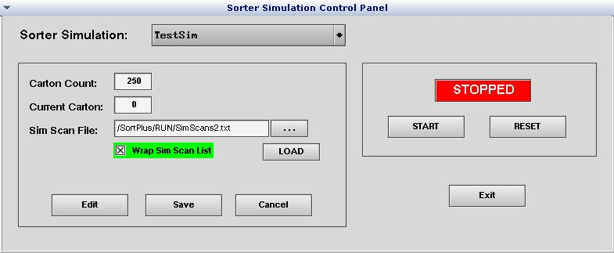

This control panel provides intuitive controls for Starting, Stopping, and Resetting a simulation as well as modifying parameters of the simulation including NumContrSrt, CurContSrt, SimScanFile, and WrapScanList.

Sorter Simulation:
The Sorter Simulation feature can simulate multiple sorters concurrently. The Sorter Simulation Control Panel allows for modification of any configured simulation by selecting the simulation you wish to modify/control in the Sorter Simulation list box:

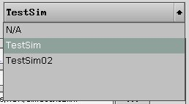

Simulation Parameters Pane:
The Simulation Parameters pane provides controls for modifying the following simulation parameters:
- Number of cartons to simulate
- The current simulation carton index
- Static simulation scan list
- Whether to recycle the scan list when the list is exhausted
To modify the Carton Count and/or Current Carton fields, click the Edit button. The Carton Count and Current Carton fields will turn red indicating they can be edited:

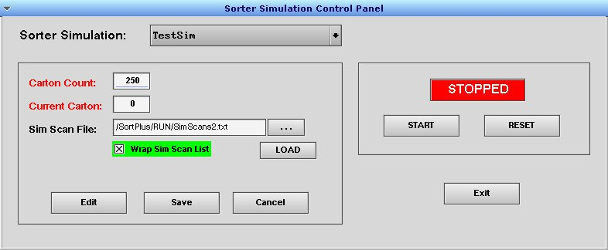

Change the values to the numbers you desire and click the Save button. If you wish to discard changes, click the Cancel button.

To select a simulation scan file, click the ellipse button (“. . .”) and browse to the scan list file as shown in the screenshot below. Click the Open button on the file browser window then click the LOAD button just below the ellipse button. You can download multiple scan lists to the Automation Controller and use this method to select the desired list at any time. Clicking the LOAD button copies the data to the simulation scan menu, making it immediately available for simulation.

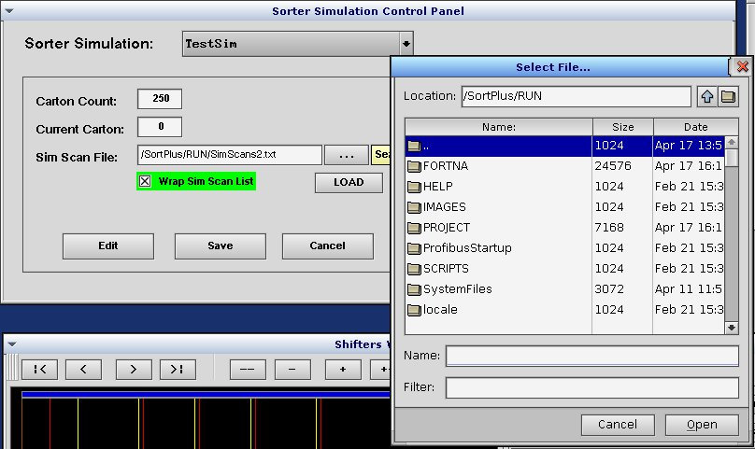

To change the Wrap Sim Scan List setting, check or uncheck the checkbox. This parameter will be automatically updated upon the checkbox change of state.

Simulation Control Pane:
The Simulation Control panel supplies controls for starting, stopping, and resetting a simulation.



In the screenshot above, clicking START will begin the selected simulation and the status field shows the simulation is currently STOPPED.

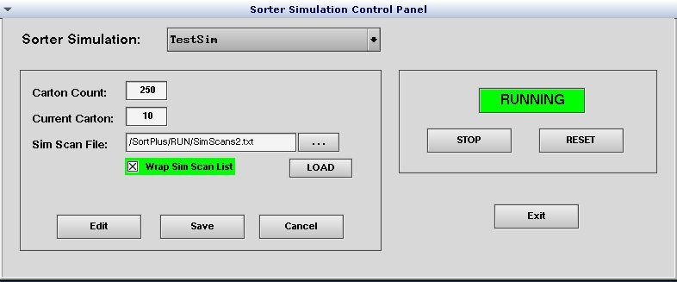

In the screenshot above, clicking STOP will halt the selected simulation and the status field shows the simulation is currently RUNNING.

The Exit button closes the Sorter Simulation Control Panel.

